**SRS DOCUMENT FOR ONLINE SHOPPING MART**

INTRODUCTION

ABSTRACT

In the current scenario, most of people enjoying to shop through online mode. Because it helps customer to shop anywhere at any time, it provides access to a wide range of products around the world and also time saving. The purpose of Online Shopping Mart is easy-to-use mobile based application for user who want to buy products. The system is based on user requirements like what kind of product they search that will comes under recommendation, add those product to their cart, add their location, make payment option, track their order, contact their delivery partner, return option and refund option. Suppose administrator wants to add products, delete sold out products, accept/reject customer orders and view their orders. Those all features comes under admin login.

SYSTEM REQUIREMENTS

FUNCTIONAL REQUIREMENT

The Functional Requirement Specification documents the operations and activities that a system is able to perform. It is designed to be read by general audience.

* Product Cata-log
* Search a product
* Add to cart & Checkout cart
* Payment option & Delivery
* Review

NON FUNCTIONAL REQUIREMENT

* Safety Requirements
* Security Requirements
* Reliability
* Portability
* Speed

MODULES DESCRIPTION

1. User need to enter their email id and password. The password must contain at least two numbers, one alphabet, one special character. Then only site will be more safe and speed.
2. Product cata-log module organize and display a wide range of product for purchase and also filter the product for specific user needs. It enables efficient management of product listing, categorization and search functionality.
3. User once login the site, user can view all the product details like cost, previous customer review, image of product and special feature of product.
4. Once user choose their product, click ‘add to cart’ and choose the quantity. After that redirect to the user location access or enter address manually, then select the payment option. After successful payment, user can track their order.
5. Admin will able to login the site and admin will have access to the all database as well as the user account but ha has the maximum privileges. Anyone who is not registered will not be able to purchase the products.

SYSTEM ARCHITECTURE

FLOW CHART

Go to the App

Yes

NoN

Sign up

Registered??e

Change information

Place order

Is information correct?

Select payment method

Review Order

Enter shipping information

Add to cart

Choose product

Sign in

NoN

Yes

USECASE DIAGRAM

In this use case diagram displays relations between buyer and administrator. The use case diagram of the online shopping mart shows how users browse, add products to their carts, check out, manage their accounts, and view order histories. To enable smooth shopping experiences, the system offers tools including product catalogs, cart management, payment processing, and account administration.

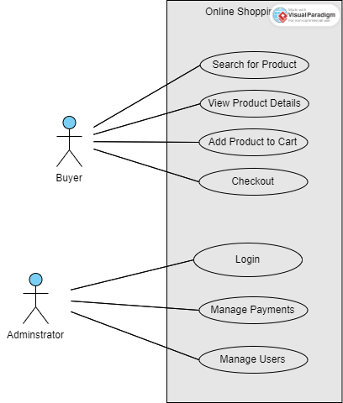

CLASS DIAGRAM

The basis of an online shopping platform is the OnlineShoppingMart class, which handle orders, payments, customers, and products. It makes for easy browsing, buying, and handling users, ensuring a great shopping experience.

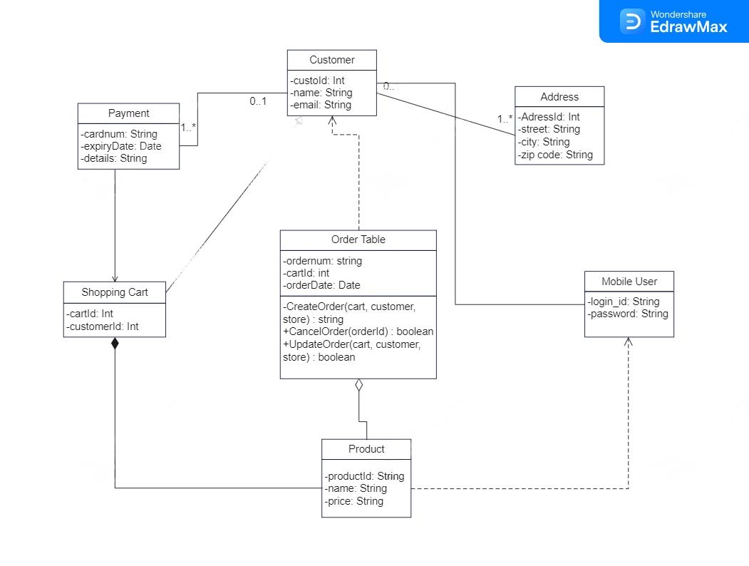

SEQUENCE DIAGRAM

Users start the online shopping mart process by searching through the website's catalog to find the products they want. These products are chosen and then added in an online shopping your cart for further analysis. When a user wants to buy something, they enter their payment and delivery details at the checkout. After confirming this data, the system safely completes the payment transaction. The order is confirmed and the purchased items are scheduled for shipment to the given address following successful payment. This process maintains users' purchases secure while providing a seamless and convenient ordering experience.

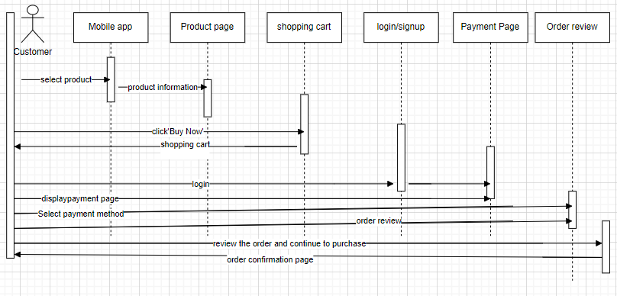

CONCLUSION

In conclusion, the online shopping mart's Software Requirements Specification (SRS) document provides a detailed description of the system's procedure, features, and user interface. It explains each one of the system's needs, such as its goals, limitations, and functional requirements. This provides the development team with a strong base upon which to work while they carry out the project. The SRS document maintains alignment between stakeholders' expectations and the final product providing a clear roadmap for the design and implementation phases. This helps to create an easy and user-friendly online shopping experience.